Editors - Properties Editor - View Layer Tab
View Layer 2
View Layer Panel - All Renderers 3
Use for Rendering 3
Animate Property 3
Render Single Layer 3
Cycles - Filter Panel 3
Environment 3
Surfaces 4
Freestyle 4
Ambient Occlusion 4
Hair 4
Cycles - Passes Panel 4
Data 4
Combined 4
Mist 4
Vector 4
Object Index 4
Denoising Data 4
Z 4
Normal 5
UV 5
Material Index 5
Render Time 5
Alpha Threshold 5
Light 5
Diffuse 5
Direct 5
Indirect 5
Color 5
Glossy 5
Direct 5
Indirect 5
Color 5
Transmission 6
Direct 6
Indirect 6
Color 6
Subsurface 6
Direct 6
Indirect 6
Color 6
Volume 6
Direct 6
Indirect 6
Color 6
Emission 6
Environment 6
Shadow 7
Ambient Occlusion 7
Cryptomatte 7
Object 7
Materials 7
Asset 7
Levels 7
Accurate Mode 7
Cycles - Denoising Panel 7
Enable 7
Feature Strength 7
Relative Filter 8
Diffuse 8
Direct 8
Indirect 8
Glossy 8
Direct 8
Indirect 8
Transmission 8
Direct 8
Indirect 8
Subsurface 8
Direct 8
Indirect 8
Eevee - Passes 9
Combined 9
Z 9
Mist 9
Normal 9
Ambient Occlusion 9
Subsurface Direct 9
Subsurface Color 9
Animate Property 9

View Layer

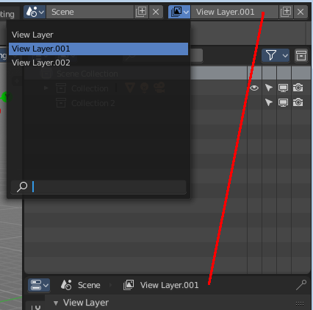
View Layers reference to Scene collections. They allow to set their visibility, selectability and other options. Each View Layer can use any collection you wish, and multiple View Layers can use the same collections or different collections.
Usually you have just one View layer for the whole scene. But you can create more View layers in the header, and rename them there.

View layers are by default active for all collections. You have to exclude it in the RMB menu for the specific layers. This can be done in the Outliner. In the shot below Collection 2 is already excluded from View Layer 001. The text is greyed out, and the functionality is missing. This collection is not available for View Layer 001.
Right click at the Collection, and chose View Layer -> exclude
In the same menu you can also re enable the collection for a view layer.

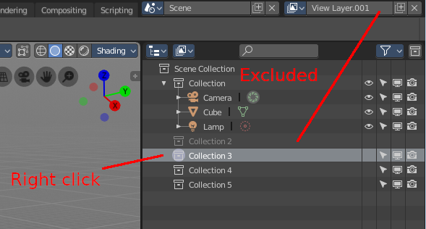
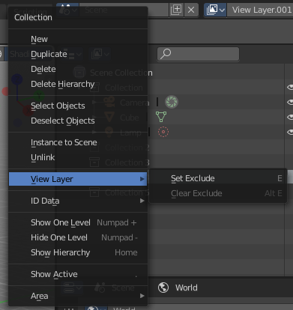

The different render engines uses different view layer functionality. And so the panels and available options differ.

View Layer Panel - All Renderers

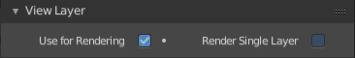
Use for Rendering
Disable or enable the render layer.

Animate Property
This property can be animated. Activating this button sets a keyframe.

Render Single Layer
Only render the active layer. This just works for rendering from the interface. Rendering from command line ignores this setting.

Cycles - Filter Panel

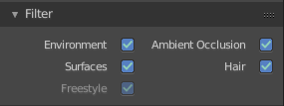
Environment
Render Sky in this layer.

Surfaces
Render solid surfaces in this layer.

Freestyle
Render stylized strokes in this layer. This feature is greyed out when Freestyle is not activated.

Ambient Occlusion
Render Ambient Occlusion in this layer.

Hair
Render Hair in this layer.

Cycles - Passes Panel
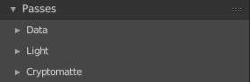
The passes panel is divided into three sub menus. Data, Light and Cryptomatte.

Here you enable or disable passes for single features.

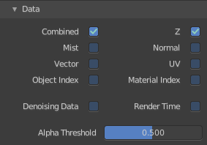
Data

Combined
Deliver full combined RGBA Buffer.

Mist
Deliver Mist factor pass. 0.0 - 1.0.

Vector
Deliver Speed Vector pass.

Object Index
Deliver Object Index pass.

Denoising Data
Store the denoising feature passes and the noisy image.

Z
Deliver Z Value pass.

Normal
Deliver Normal pass.

UV
Deliver UV pass.

Material Index
Deliver Material Index pass.

Render Time
Render time in miliseconds per sample and pixel.

Alpha Threshold
Z, Index, Normal, UV and Vector passes are just affected by surfaces with alpha transparency equal or higher this threshold.

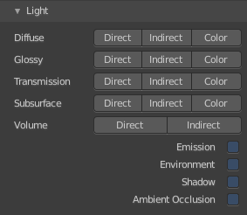
Light

Diffuse

Direct
Deliver direct pass.

Indirect
Deliver indirect pass.

Color
Deliver color pass.

Glossy

Direct
Deliver direct pass.

Indirect
Deliver indirect pass.

Color
Deliver color pass.

Transmission

Direct
Deliver direct pass.

Indirect
Deliver indirect pass.

Color
Deliver color pass.

Subsurface

Direct
Deliver direct pass.

Indirect
Deliver indirect pass.

Color
Deliver color pass.

Volume

Direct
Deliver direct pass.

Indirect
Deliver indirect pass.

Color
Deliver color pass.

Emission
Deliver Emission pass.

Environment
Deliver Environment pass.

Shadow
Deliver Shadow pass.

Ambient Occlusion
Deliver Ambient Occlusion pass.

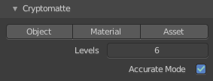
Cryptomatte
Cryptomatte passes can be used to isolate objects or materials or assets in compositing.

Object
Render Cryptomatte Object Pass.

Materials
Render Cryptomatte Materials Pass.

Asset
Render Cryptomatte Asset Pass.

Levels
How many unique objects can be distinguished per pixel

Accurate Mode
Generate a more accurate cryptomatte pass. This feature renders at the CPU only, and comsumes more memory.

Cycles - Denoising Panel

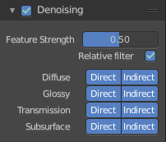
Rendering with an unbiased renderer like Cylces means you will always have some noise in the image. This noise can be reduced by Denoising. Denoising is a post process step that smoothes out noise.

Enable
In the header is a checkbox to enable the denoising.

Feature Strength
Controls the removal of noisy image passes. Lower values preserves more detail. But aren't as smooth.

Relative Filter
Use a relative threshold instead of an absolute one hwen removing pixels that don't carry information. This can help to reduce artifacts. But it might cause detail loss around edges.

Diffuse

Direct
Denoise the direct diffuse lighting.

Indirect
Denoise the indirect diffuse lighting.

Glossy

Direct
Denoise the direct Glossy lighting.

Indirect
Denoise the indirect Glossy lighting.

Transmission

Direct
Denoise the direct Transmission lighting.

Indirect
Denoise the indirect Transmission lighting.

Subsurface

Direct
Denoise the direct Subsurface lighting.

Indirect
Denoise the indirect Subsurface lighting.

Eevee - Passes
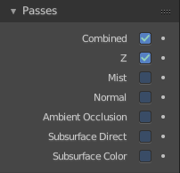
Here you enable or disable passes for single features.

Combined
Deliver full combined RGBA Buffer.

Z
Deliver Z Value pass.

Mist
Deliver Mist factor pass. 0.0 to 1.0

Normal
Deliver Normal pass.

Ambient Occlusion
Deliver Ambient Occlusion pass.

Subsurface Direct
Deliver Subsurface Direct pass.

Subsurface Color
Deliver Subsurface Color pass.

Animate Property
These properties can be animated. Activating this button sets a keyframe.

